**How to update your website**

Contents

INTRODUCTION: 2

LOG IN DETAILS 5

UPLOADING NEW IMAGES 6

DELETING IMAGES 7

EDITING THE MAIN PAGE OF YOUR WEBSITE - http://www.femaleboxingcoach.com/ 8

Change **Showcase** section 8

Changing the Background Picture 9

Text 11

Change **About Ana** Section on Homepage 12

Change **Featured Classes** Section on Homepage 14

Add/Delete A New Class to The **Schedule** Area on Homepage 16

To Delete A Schedule Item 19

Change Images on **Homepage Gallery** Section 20

Add/Delete A New **Testimonial** on Homepage 21

To edit a testimonial: 23

To add a new testimonial / delete a testimonial 24

Editing The **Google Map** On Homepage: 25

EDITING THE ABOUT PAGE: - http://www.femaleboxingcoach.com/about/ 27

Editing the page: 27

To add a new paragraph: 28

EDITING THE CLASSES PAGE - http://www.femaleboxingcoach.com/classes/ 30

Edit A Class to Classes Page 30

Add A New Class to Classes Page 32

To delete a class 34

EDITING THE GALLERY PAGE - http://www.femaleboxingcoach.com/gallery/ 35

Add A New Picture to The Gallery Page 35

Delete an image from the Gallery Page 36

UPDATES TO YOUR SITE 36

BACK UPS 37

# INTRODUCTION:

Your website has 4 pages: the **home page**, **about page**, **classes page** & a **gallery page**.

**Home page (main page)** - <http://www.femaleboxingcoach.com/>

|  |  |
| --- | --- |
|  | **SHOWCASE** –  you will be able to change the picture and text |
|  | **ABOUT ANA** – can change title, text, picture & button text |
|  | **FEATURED** **CLASSES** –  Can change text and image |
|  | **SCHEDULE** –  Can add or remove your classes from this section |
|  | **TESTIMONIALS** – you can add new testimonials – they scroll to the left so that it shows 2 at a time |
|  | **HOME GALLERY** – you can choose 4 pictures to display in this section |
|  | **CONTACT** – this is where map is displayed and also the contact form |

**About page** - <http://www.femaleboxingcoach.com/about/>

|  |  |
| --- | --- |
|  | This page is all about you – it can all be changed / edited |

**Classes Page** - <http://www.femaleboxingcoach.com/classes/>

|  |  |
| --- | --- |
|  | This page has the services you provide and also information for each of your classes |

**Gallery Page** - <http://www.femaleboxingcoach.com/gallery/>

|  |  |
| --- | --- |
|  | This page has the services you provide and also information for each of your classes |

# LOG IN DETAILS

To make any changes to your website, you will need to login to the admin area:

<http://www.femaleboxingcoach.com/wp-admin/>

USERNAME: anaboxing

PASSWORD: Sticksandstones82

Once you have logged in you will see your ***DASHBOARD******AREA***:

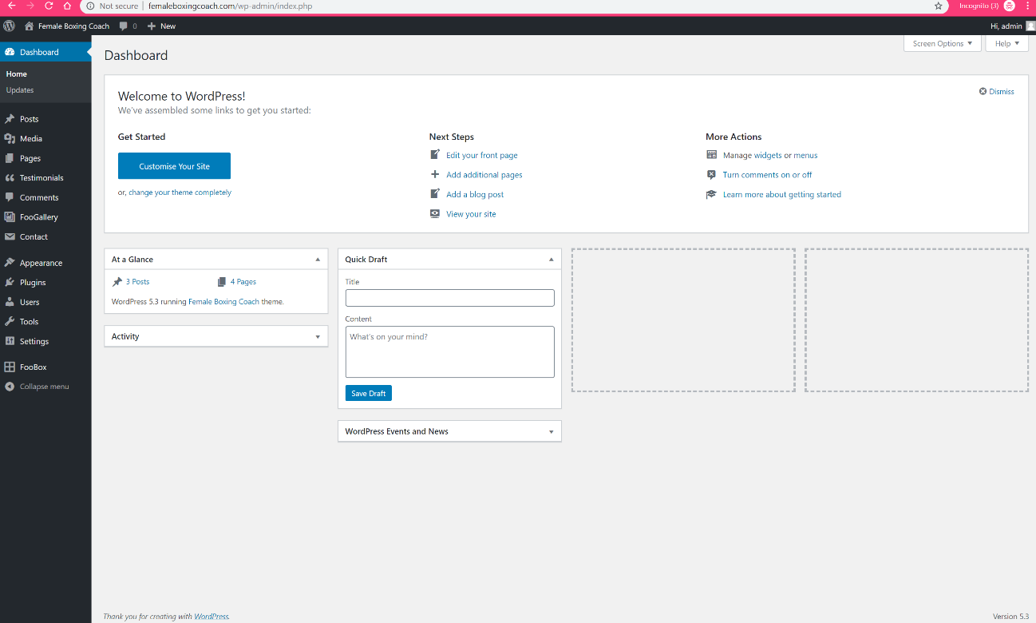

This is where you can edit any part of your site using the left-hand side options.

# UPLOADING NEW IMAGES

To upload a new image – go to the dashboard area:

***MEDIA*** -> ***LIBRARY*** -> ***ADD NEW***

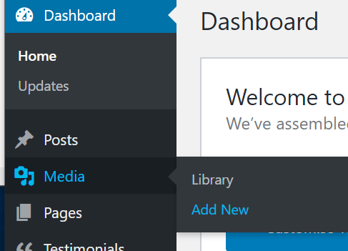

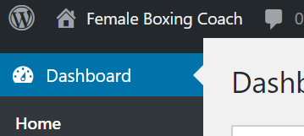

You can then drag the file into the square or click on Select files and choose the picture you want to add

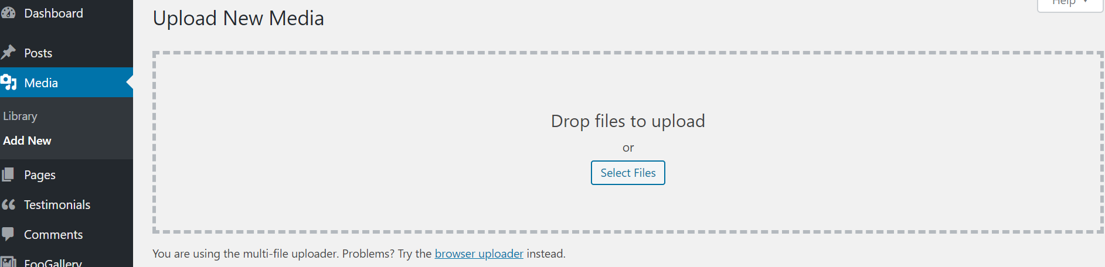

Once this is done you will see the new image/images show at the bottom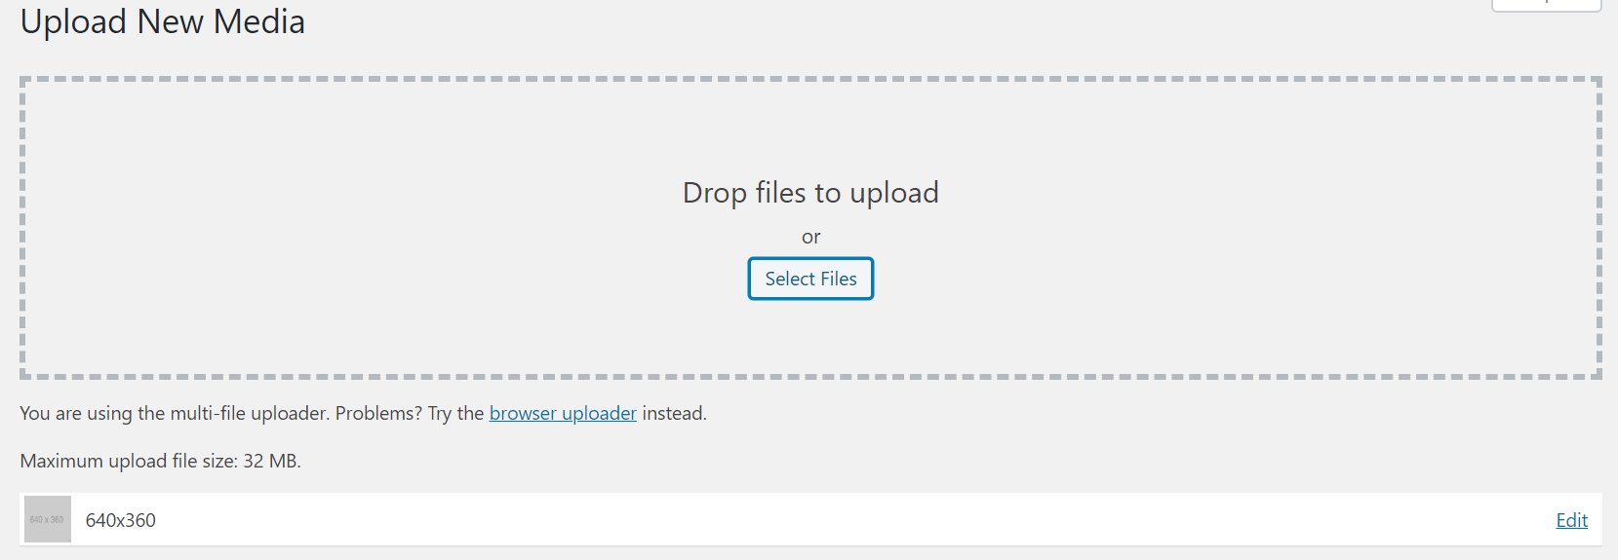

All Done!

# DELETING IMAGES

To delete an image, go to ***DASHBOARD*** -> ***MEDIA***

Click on the image you would like to delete then press “***DELETE PERMANENTLY***” (bottom right circle) – then a pop will ask if you are sure and if you are click ***OK.***

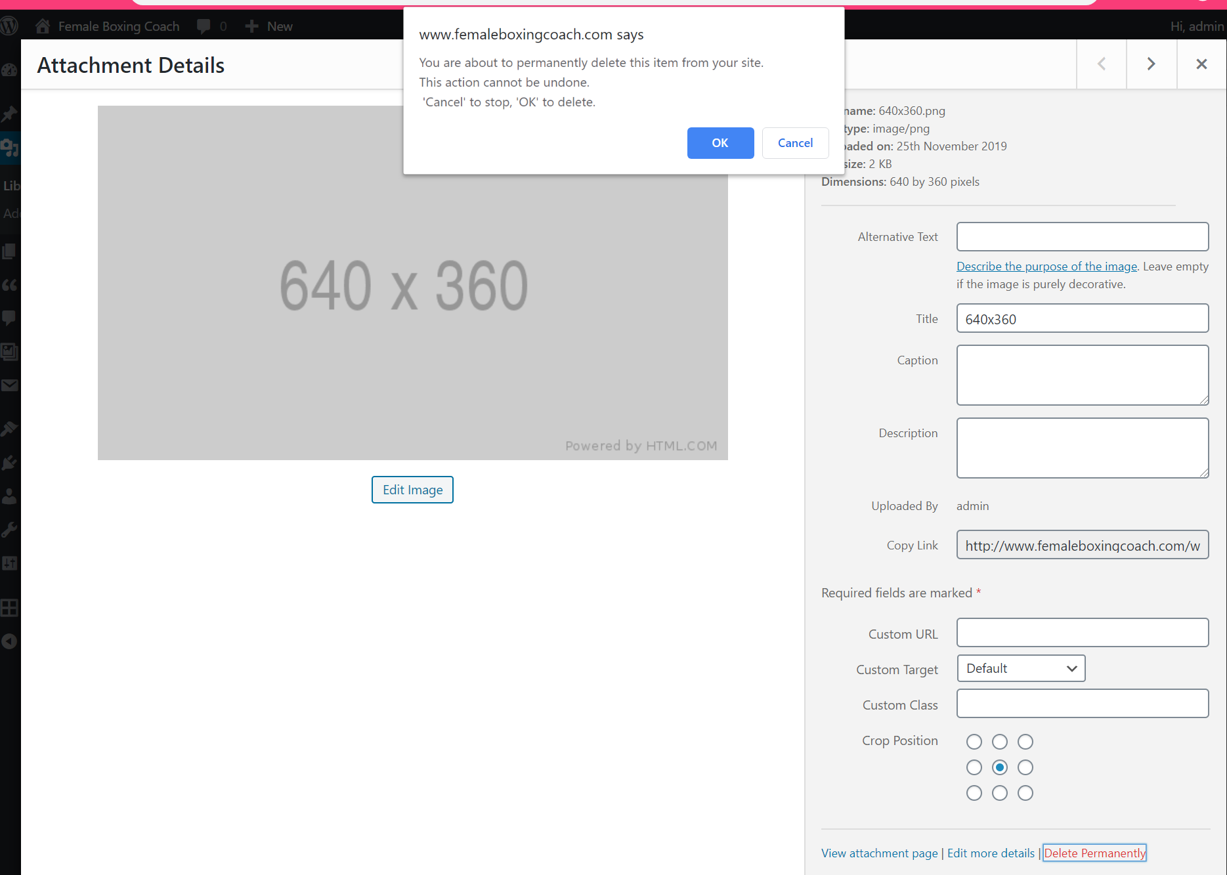

**2**

**1**

Done!

# EDITING THE MAIN PAGE OF YOUR WEBSITE - <http://www.femaleboxingcoach.com/>

## Change **Showcase** section

The Showcase section is the big black and white photo with the text at the top of the page

On the left-hand side go to ***APPEARANCE*** -> ***CUSTOMISE*** (highlighted in blue)

You will then see this screen below – click on ***SHOWCASE***

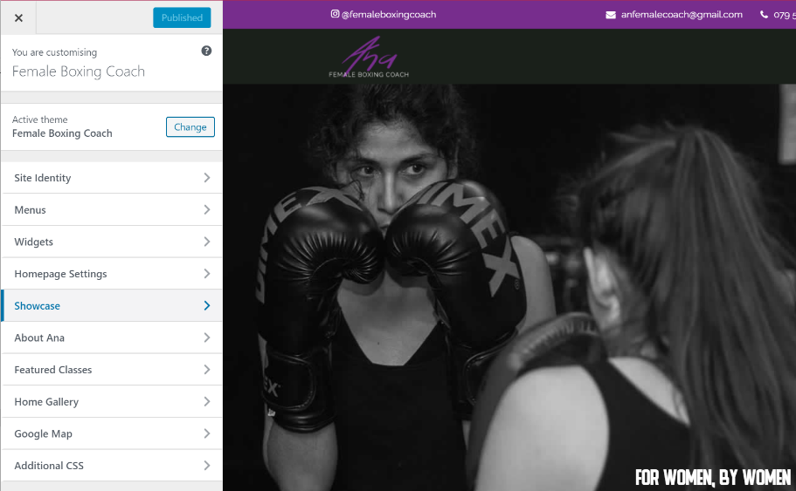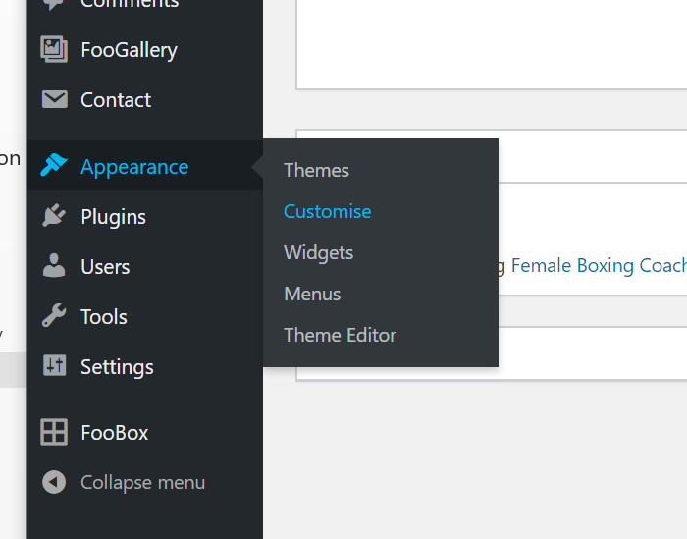

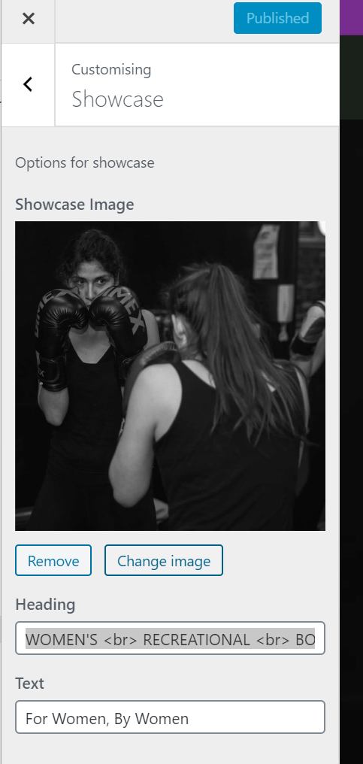

From here you can change the showcase image, change the heading text (the big purple text), and the smaller text in white

Notes on how to change these are below:

### Changing the Background Picture

To change the image, click on “***CHANGE*** ***IMAGE***” – this will then take you to your media library.

If you haven’t uploaded the image yet then select the tab “Upload files” and add the picture you would like the same way as above in **UPLOADING NEW IMAGES**

Once you have selected your image click on ***CHOOSE IMAGE***

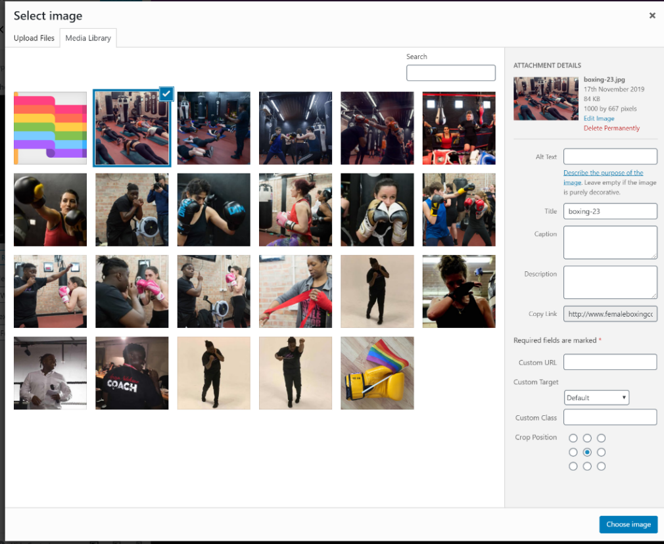

Your new image will now show up on the screen and to make it a permanent change press ***PUBLISH***

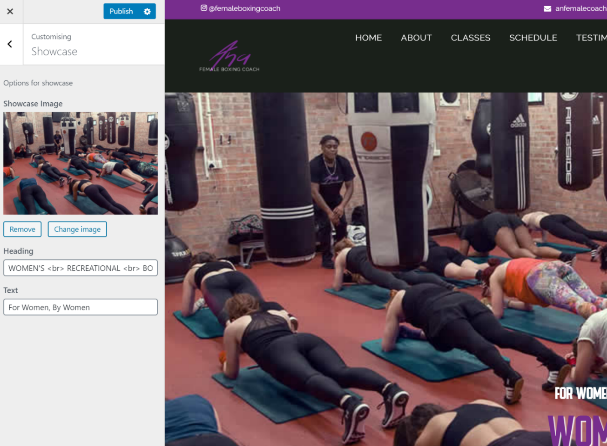

If there are any changes you have made that you don’t want to go live, then click on the ***X*** out and this will remove all your changes without saving

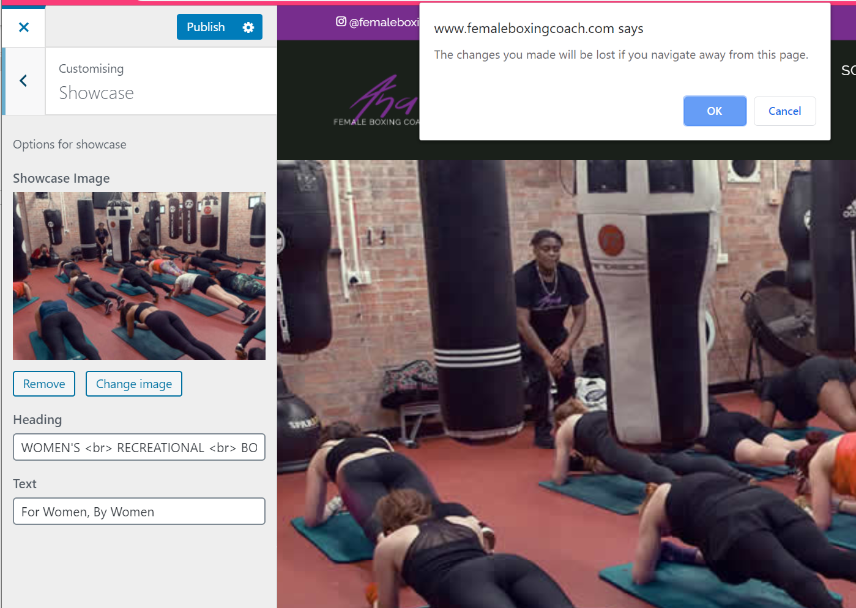

**2**

**1**

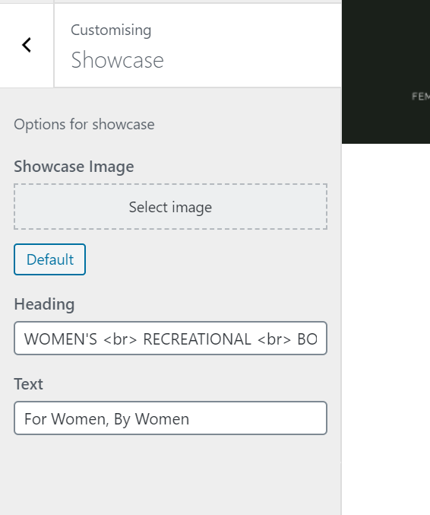

To change back to the original image – click on ***REMOVE*** (see image above circled in green)

Then click on ***DEFAULT*** (left image circled in green)

Then click on ***PUBLISH***

### Text

The default purple text is:

WOMEN'S <br> RECREATIONAL <br> BOXING

Please note that <br> means new line so add this to any text if you want it on different lines like:

Women’s

Recreational

Boxing

The white text above is

For Women, By Women

Once anything is changed you need to press ***PUBLISH*** at the top to save it and those changes will show up on the site:

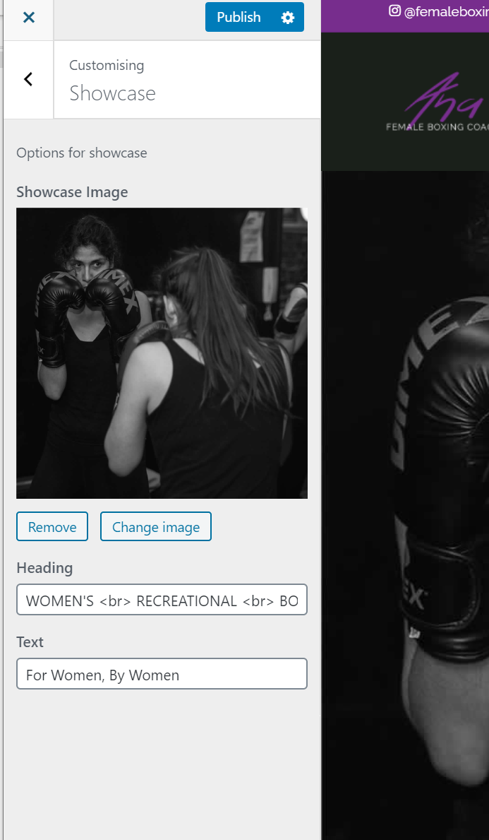

## Change **About Ana** Section on Homepage

The About Ana section on the main page is a short introduction to who you are with a button to go to the **ABOUT ANA** page where they can find out more.

On the left-hand side go to ***APPEARANCE*** -> ***CUSTOMISE*** (highlighted in blue).

Then click on ***ABOUT ANA***

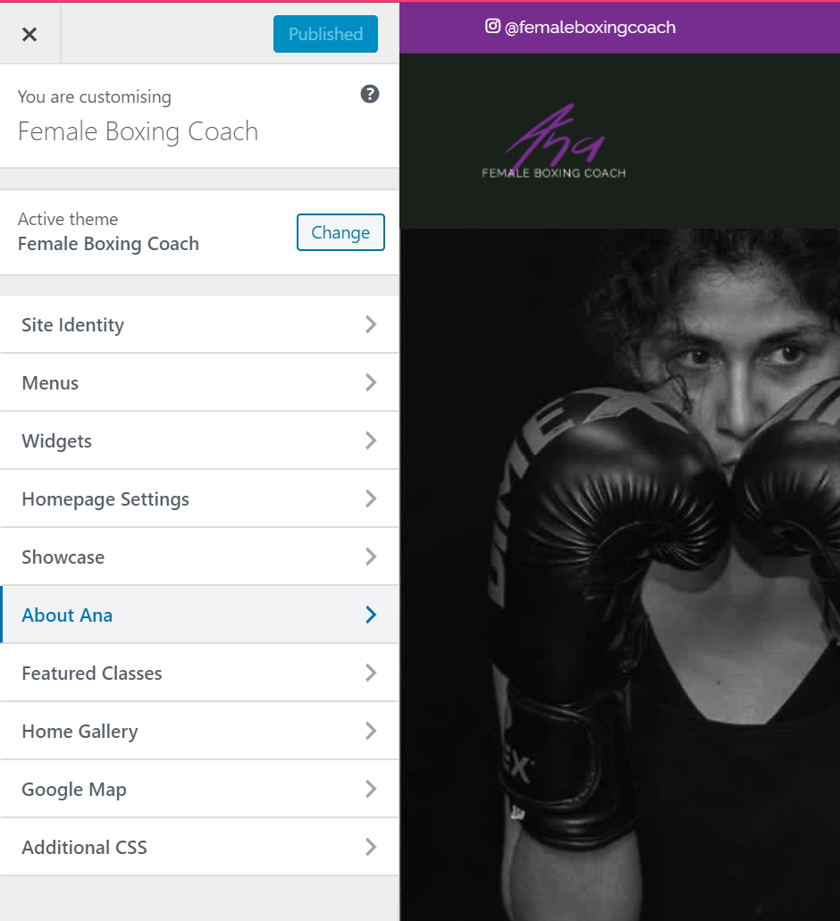

Here you can change the text, image and also what the button says below on the left-hand side:

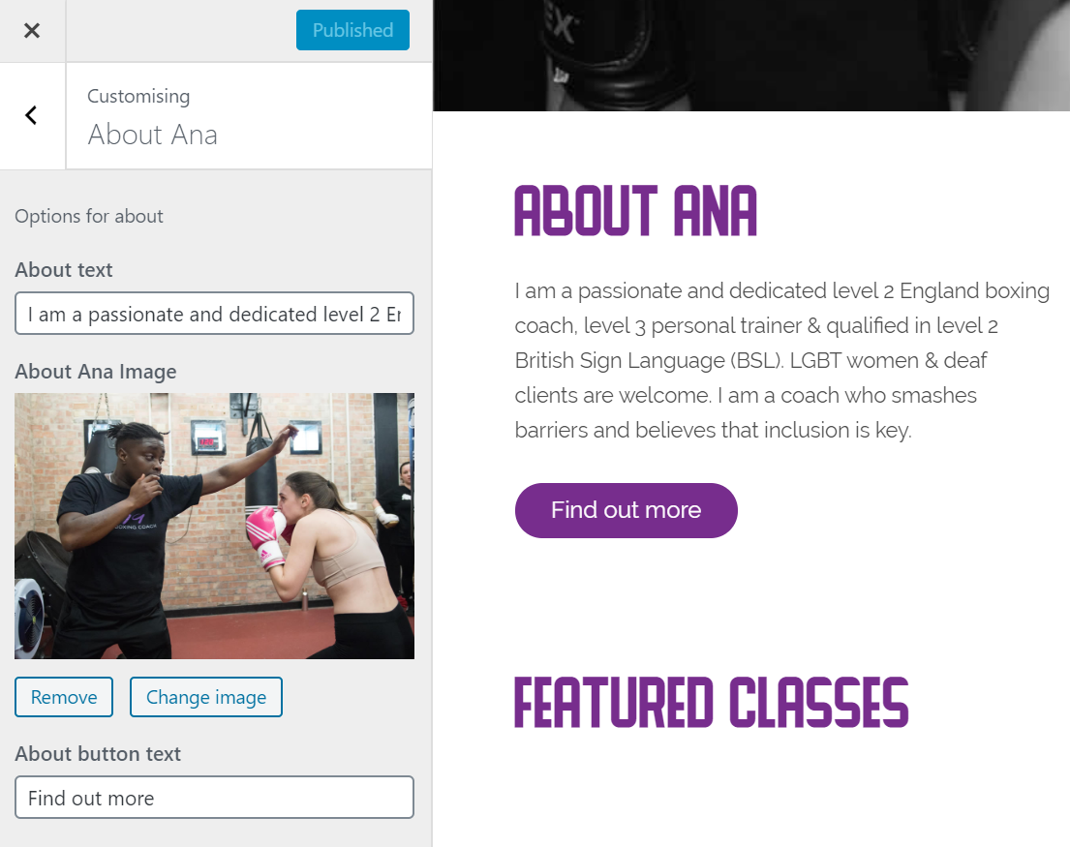

**The original text for About Text:**

I am a passionate and dedicated level 2 England boxing coach, level 3 personal trainer & qualified in level 2 British Sign Language (BSL). LGBT women & deaf clients are welcome. I am a coach who smashes barriers and believes that inclusion is key.

**About Button Text:**

Find out more

Changing an image is the same as the ***SHOWCASE AREA*** – It is the same to remove images and change back to default.

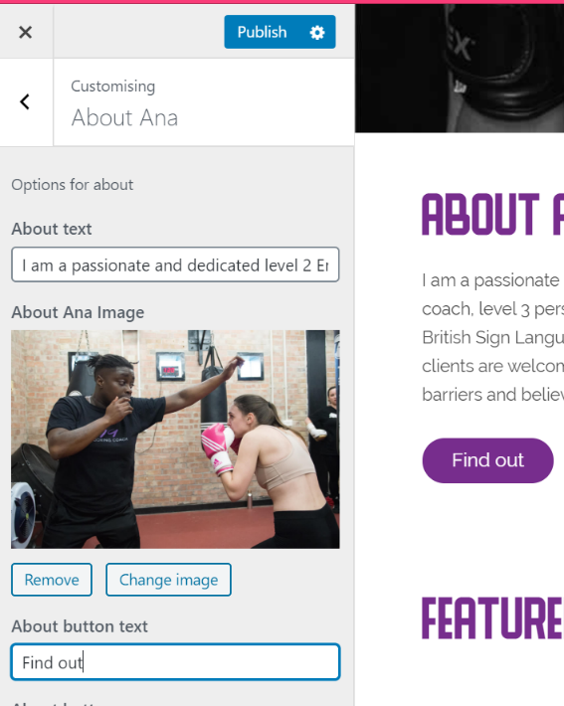

Can see what it will look like on the right – it changes as you make changes

Don’t forget to click ***PUBLISH***!

## Change **Featured Classes** Section on Homepage

The Featured Classes section on the main page shows two classes with a button to go to the **CLASSES** page where they can find out more & see more classes you provide.

On the left-hand side go to ***APPEARANCE*** -> ***CUSTOMISE*** (highlighted in blue).

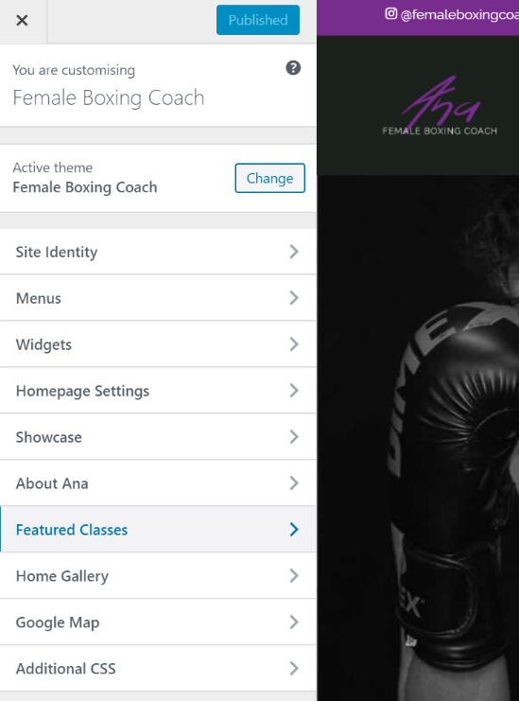Then click on ***FEATURED CLASSES***



Here you can change the class headings, class descriptions, image and also what the button says below on the left-hand side:

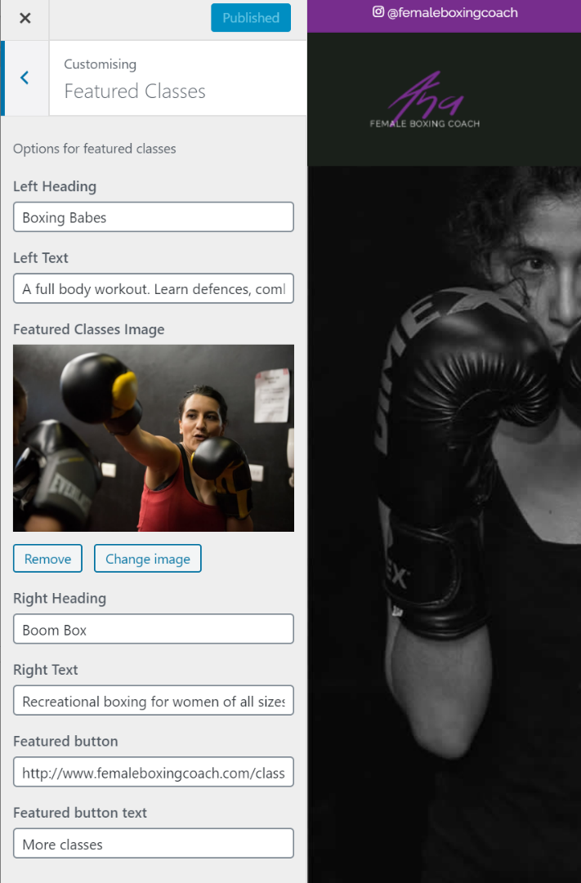

Can see what it will look like on the right – it changes as you make changes

Don’t forget to click ***PUBLISH***!

**The original text for Left heading**:

Boxing Babes

**The original text for Left Text:**

A full body workout. Learn defences, combinations, footwork and pad work. Sessions are focused on fitness and partner work, helping you build confidence, make friends, and strengthen your body and mind.<br>All abilities and fitness levels welcome!

[Remember <br> just means a new line!]

Changing an image is the same as the ***SHOWCASE AREA*** – It is the same to remove images and change back to default.

**The original text for Right** **Heading**

Boom Box

**The original text for Right Text**

Recreational boxing for women of all sizes, abilities and fitness levels. A full body workout which includes defences, combinations, footwork and partner work with pads whilst getting fit. At these sessions you get to learn the ropes of boxing and have fun whilst you exercise.<br>Please bring your own gloves if you have, limited pairs available.

**The original text for Featured Button Text**

More classes

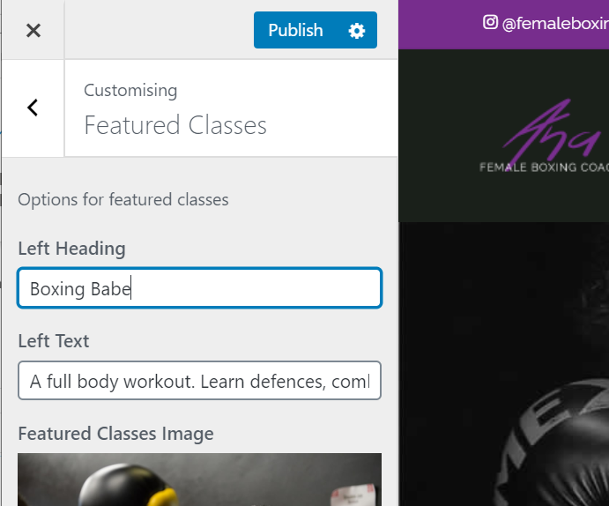

## Add/Delete A New Class to The **Schedule** Area on Homepage

This one is a bit trickier as you will need to copy in some code, but it is very easy I promise!

The Schedule section on the main page is a list of all the classes you provide with time and location with a button to go to the **CLASSES** page where they can find out more info.

On the left-hand side go to ***APPEARANCE*** -> ***CUSTOMISE*** (highlighted in blue).

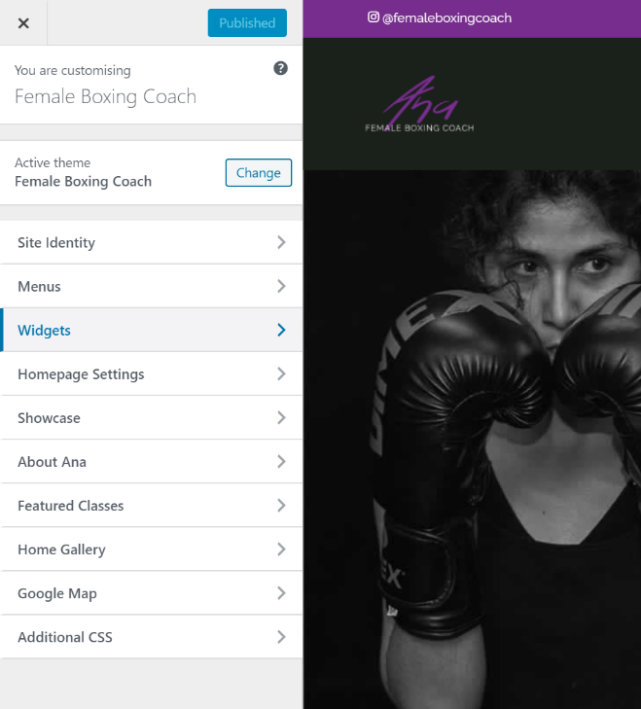Then click on ***WIDGETS***



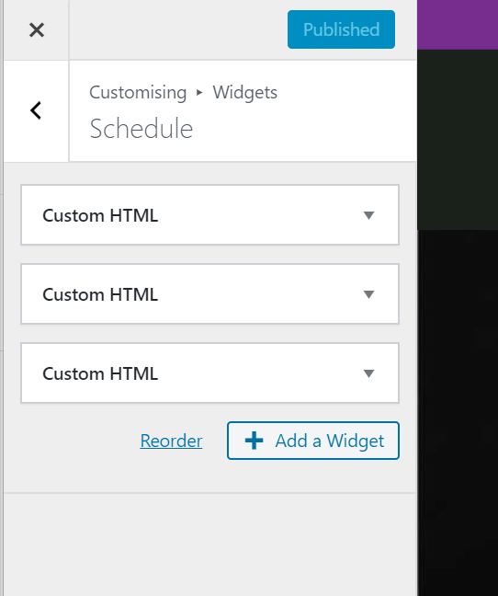

At the moment there are three boxes saying ***CUSTOM HTML*** because we have three classes on our schedule section:

*Boxing Babes,*

*Boombox and*

*Lezbox*

Each one shows up as a row on the website – see image below:

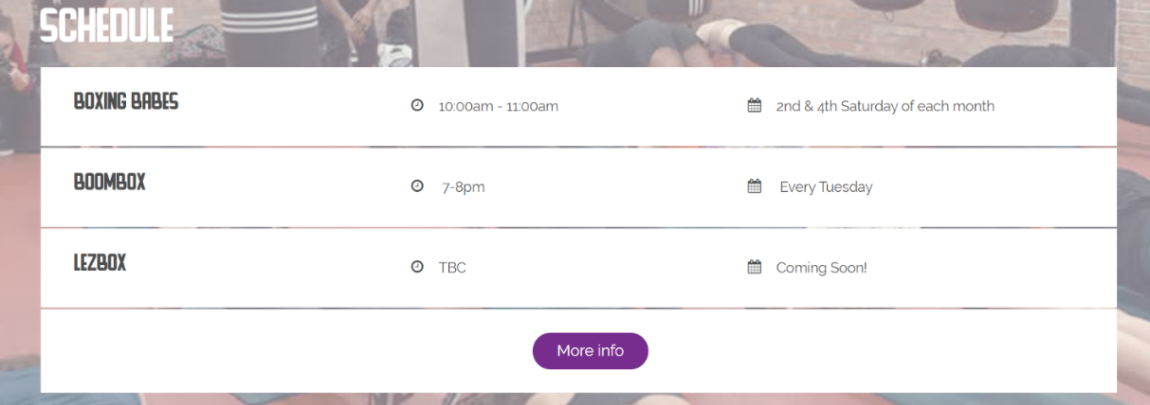

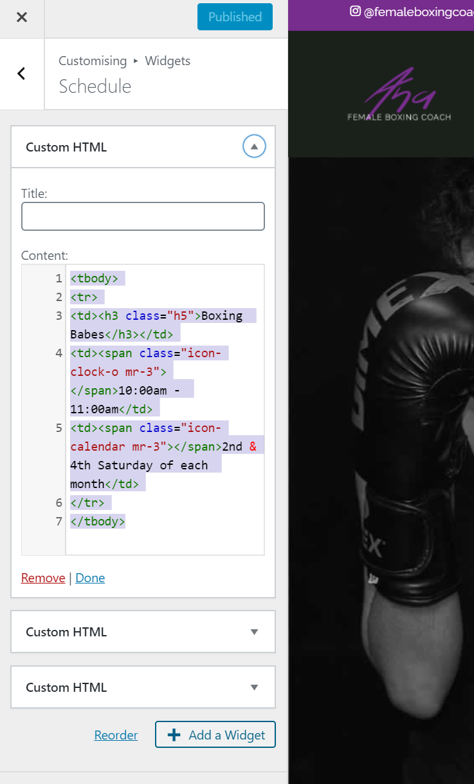

To edit a class, select which one you want to change by clicking on the arrow on the right of each of the boxes (circled in red)

Here you will see some HTML code but all you need to change is the title, time and / or dates – all that text is colour coded and is the black text. (see text below for what bits to change :) )

<tbody>

<tr>

<td><h3 class="h5">**Boxing Babes**</h3></td>

<td><span class="icon-clock-o mr-3"></span>**10:00am - 11:00am**</td>

<td><span class="icon-calendar mr-3"></span>**2nd & 4th Saturday of each month**</td>

</tr>

</tbody>

If you make any changes don’t forget to **PUBLISH**!

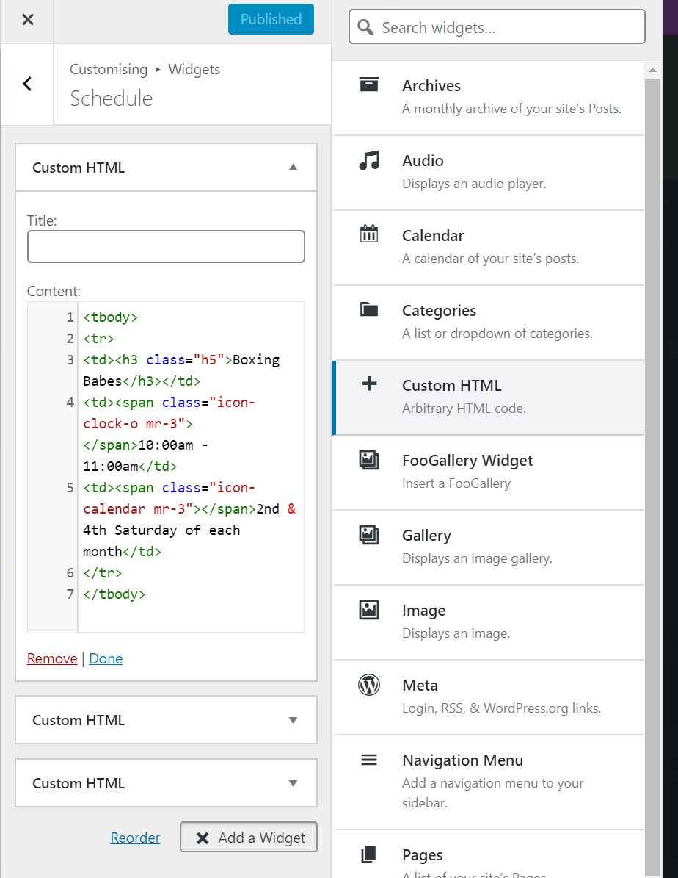

To add a new class, you will need to click on **ADD WIDGET**

Then select **CUSTOM HTML**

**2**

**1**

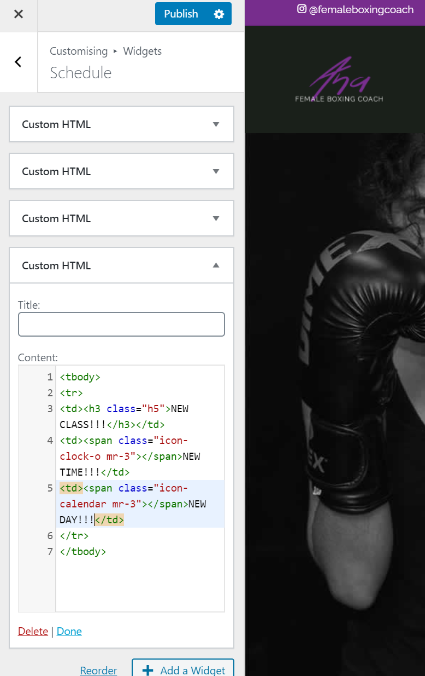

Leave title blank

In the content section – copy and paste the code below changing the class name, time & date (see image on left where it says

*NEW CLASS*

*NEW TIME*

*NEW DAY*

<tbody>

<tr>

<td><h3 class="h5">Boxing Babes</h3></td>

<td><span class="icon-clock-o mr-3"></span>10:00am - 11:00am</td>

<td><span class="icon-calendar mr-3"></span>2nd & 4th Saturday of each month</td>

</tr>

</tbody>

Press ***PUBLISH*** and you will see your new class added like this test class shows in picture below

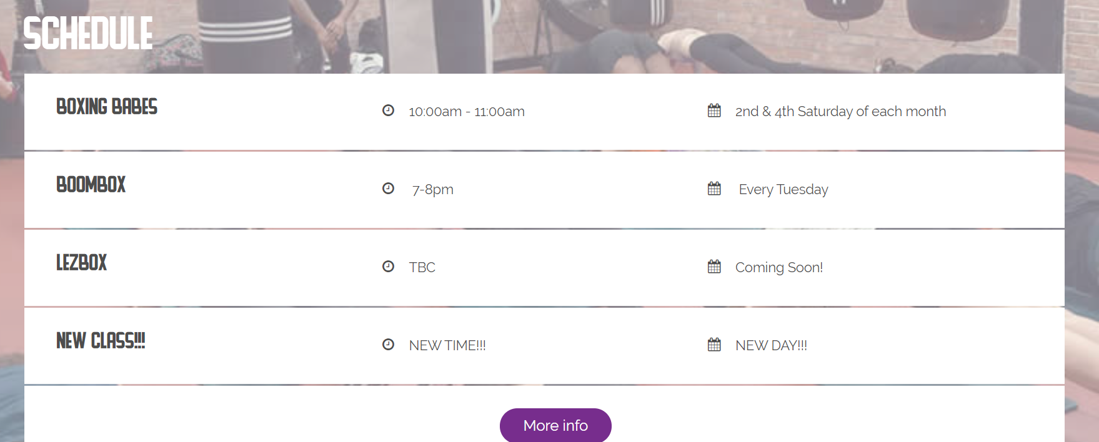

### To Delete A Schedule Item

To delete a schedule item is quite easy. In this example I’ll delete the test **NEW** **CLASS** I created above.

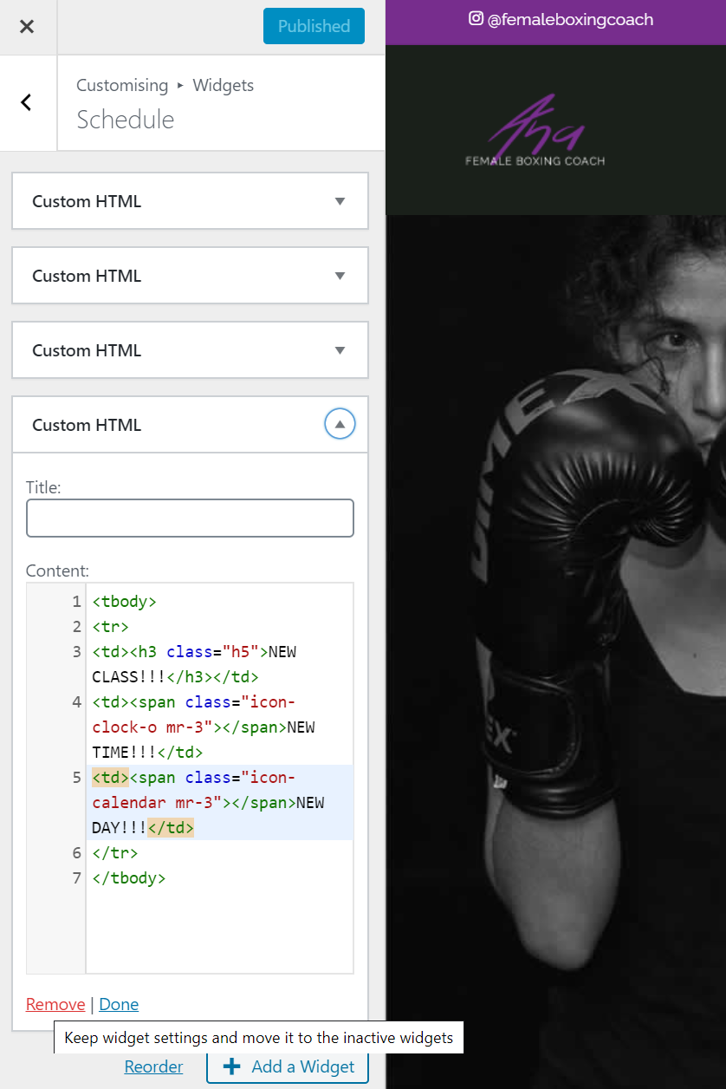

Click on the arrow beside the class you would like to remove from the schedule list

Then click on **REMOVE.**

Then click **PUBLISH**

Done!

And now there are three Custom HTML boxes not 4.

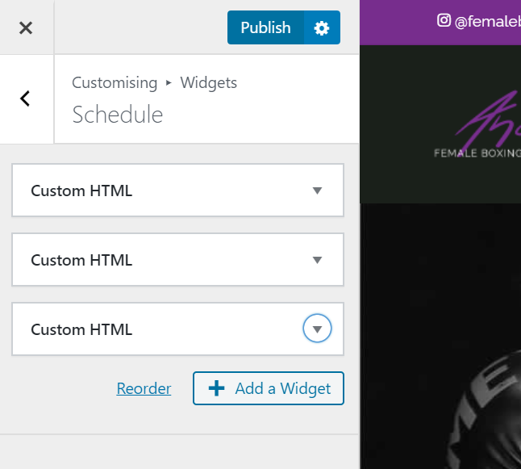

## Change Images on **Homepage Gallery** Section

The **home gallery** section on the main page is a selection of 4 images that you would like displayed on your main homepage.

On the left-hand side go to ***APPEARANCE*** -> ***CUSTOMISE*** (highlighted in blue).

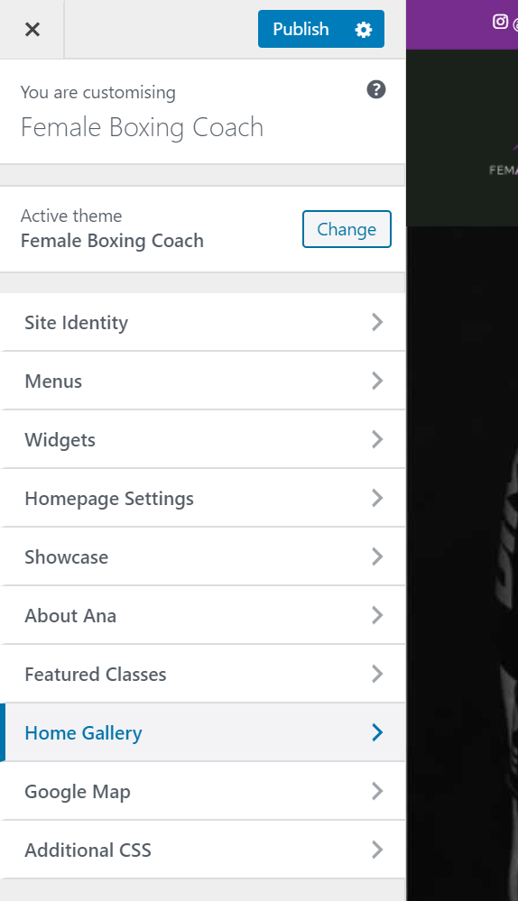Then click on ***HOME GALLERY***



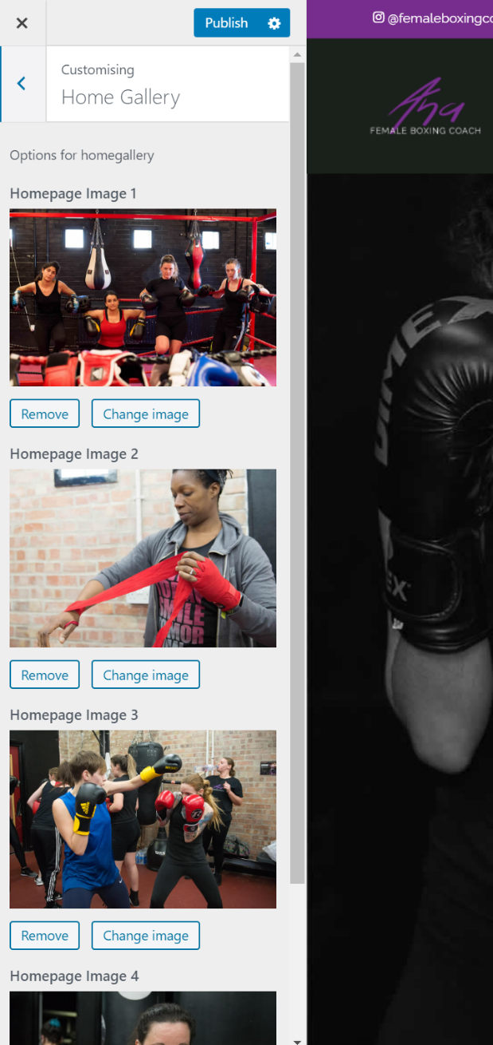

Here we can see the four selected images and change them the same way as we change images in the ***SHOWCASE AREA*** – It is the same to remove images and change back to default.

Then click **PUBLISH**

## Add/Delete A New **Testimonial** on Homepage

Make sure you are in Dashboard area below: <http://www.femaleboxingcoach.com/wp-admin/>

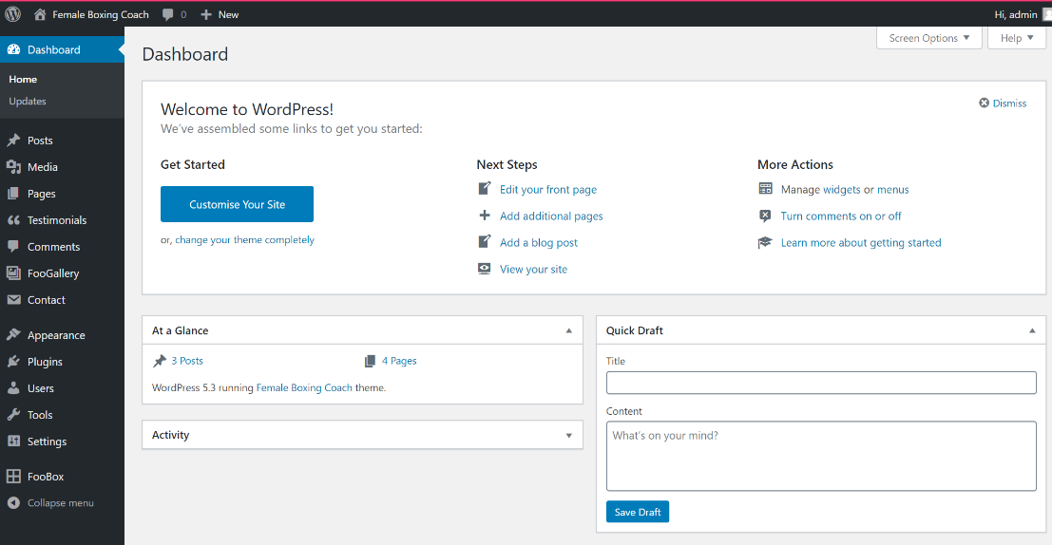

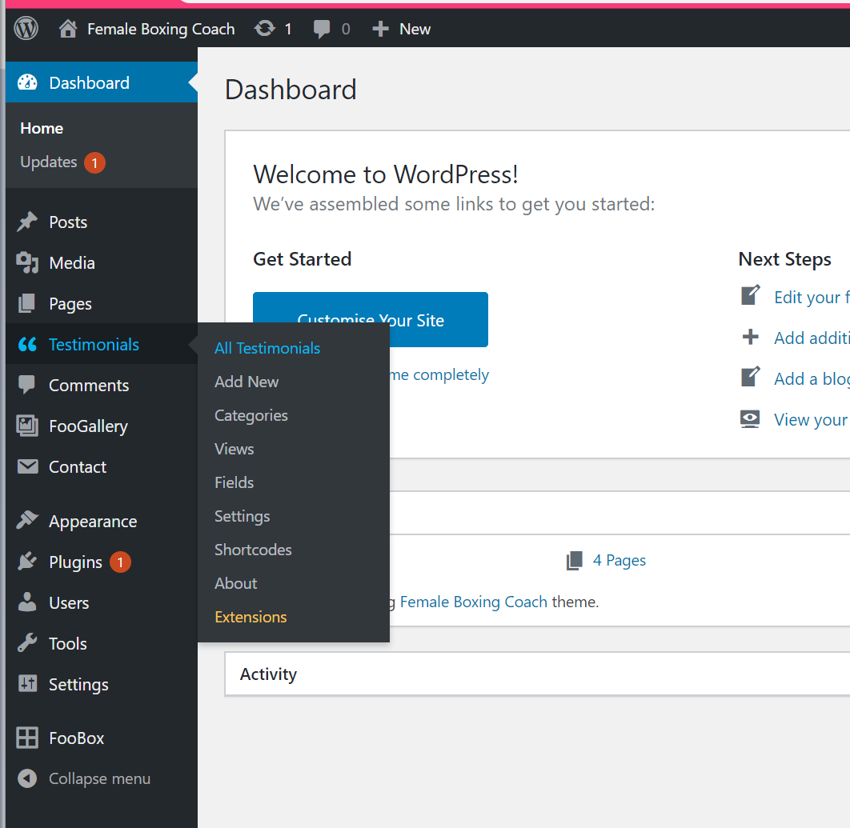

Select ***TESTIMONIALS*** -> ***ALL TESTIMONIALS*** (highlighted in blue)

In here we can see all the testimonials we have that our main homepage testimonials section scrolls through. (see below)

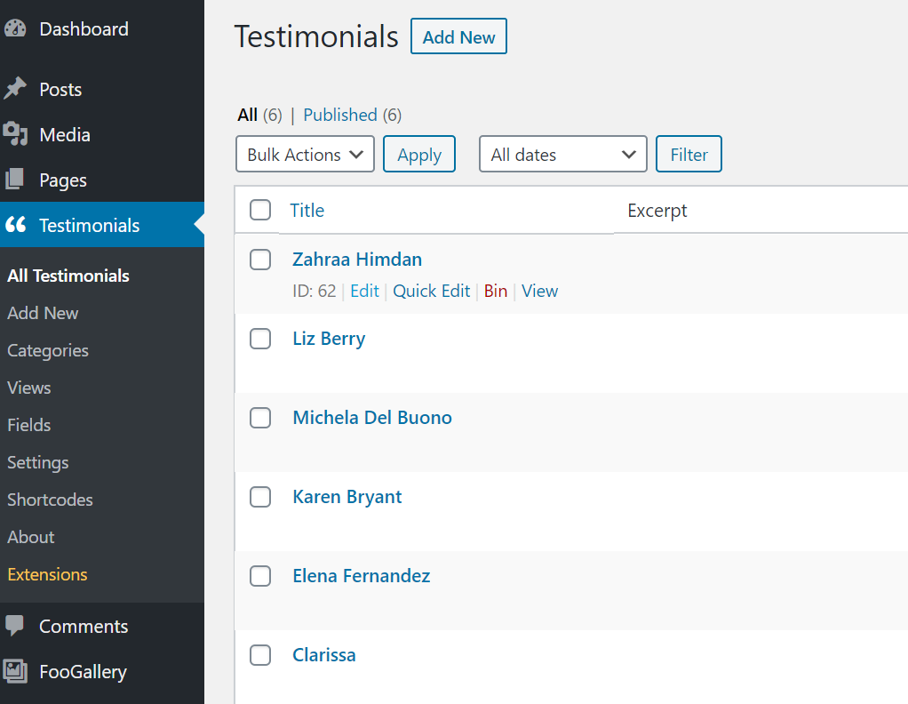

### To edit a testimonial:

In image above we can see all the testimonials – if you hover over a name like Zahraa’s, some options appear – click on edit.

Then we are taken to a page like the one below – you can change the text and name but leave all other bits blank, once you’re done click on **UPDATE** (this makes your changes permanent and is the same as the **PUBLISH** button)

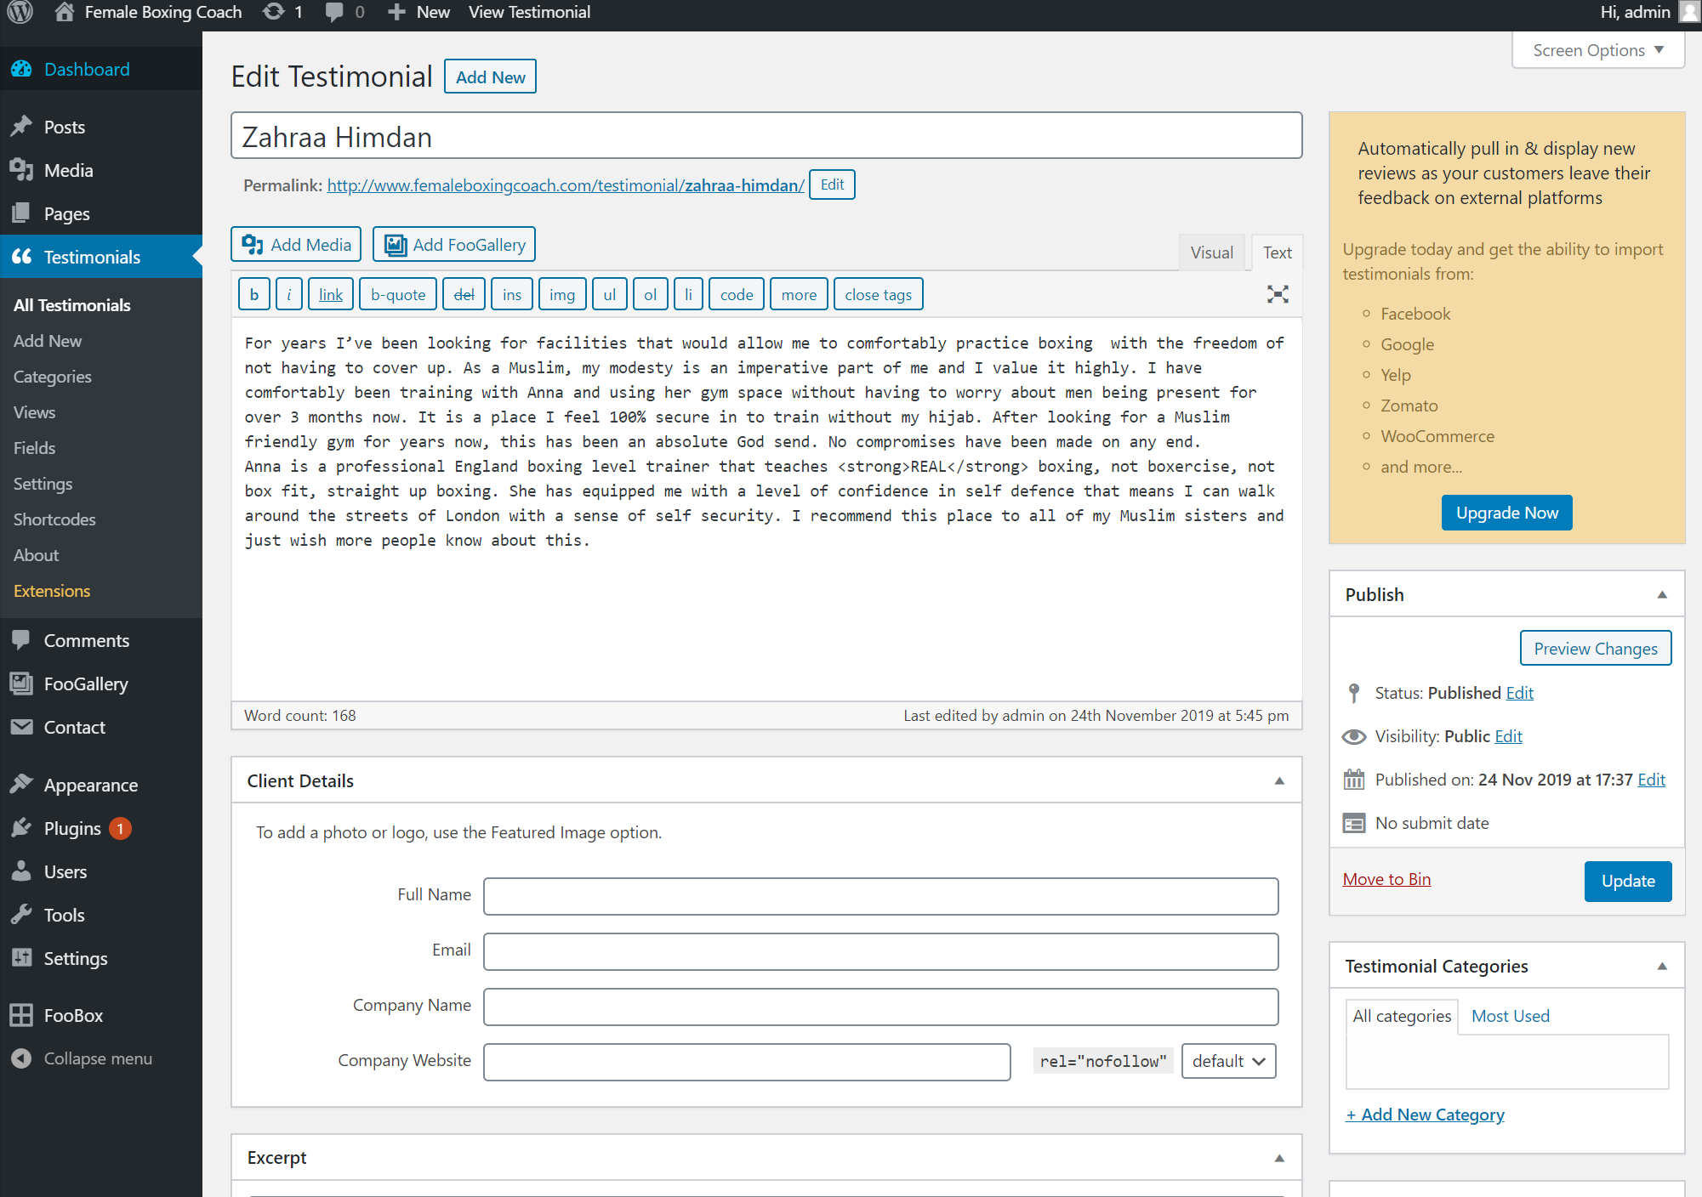

### To add a new testimonial / delete a testimonial

click on ***ADD NEW*** at the top of the page:

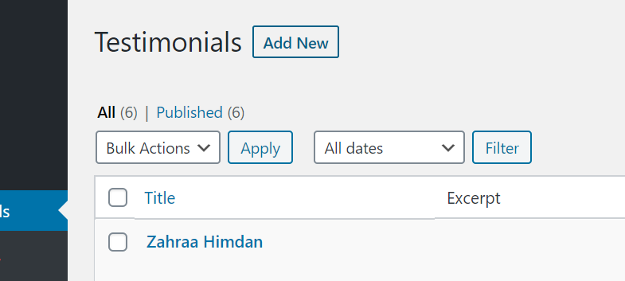

From here all you need to do is fill in the name and then the client’s testimonial – it has a spellcheck function so you should be ok for grammar :)

Then click on ***PUBLISH*** if you want it to go live or you can click on ***SAVE DRAFT*** and come back to it later and it won’t show on your website until you publish it.

To delete it, click on ***MOVE TO BIN* –** this is the same for all testimonials if you want to delete them.

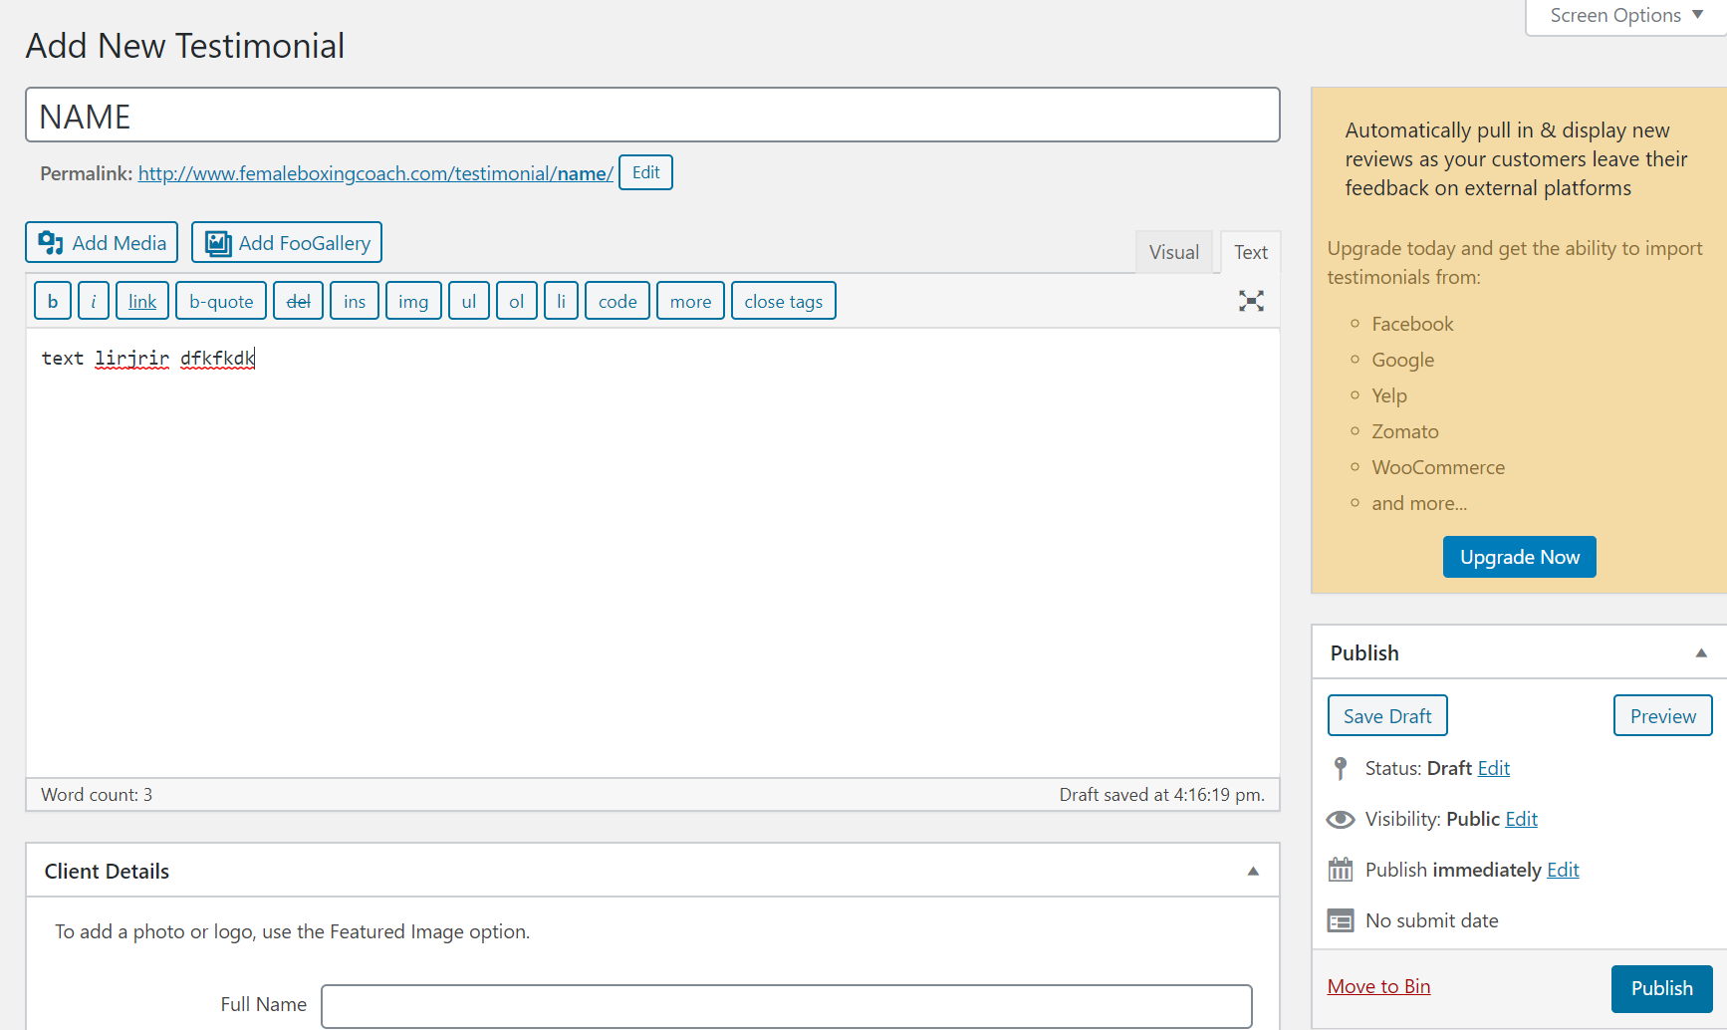

## Editing The **Google Map** On Homepage:

You will need to change this when you have new classes that you want to show the location for : at the moment this is attached to my google account so when you need to add a new location for a class – you can let me know or you can add all the classes on your google maps. I used this tutorial - <https://tribulant.com/blog/wordpress/easy-embedding-a-google-map-with-multiple-markers-to-your-site/> - Section 2: Embedding Your Google Map Manually – once you have added your classes you can get a link and it will look similar to the following:

<iframe src= ”**https://www.google.com/maps/d/embed?mid=1N_yd0ruKfnYn52CaaNaWaPfbs7XY5v1A**" width="640" height="480"></iframe> -

We don’t need all that all we need is the link so delete everything except the website link:

https://www.google.com/maps/d/embed?mid=1N_yd0ruKfnYn52CaaNaWaPfbs7XY5v1A

and this is what you will copy and paste into the field below

To add this to your site go to:

On the left-hand side go to ***APPEARANCE*** -> ***CUSTOMISE*** (highlighted in blue).

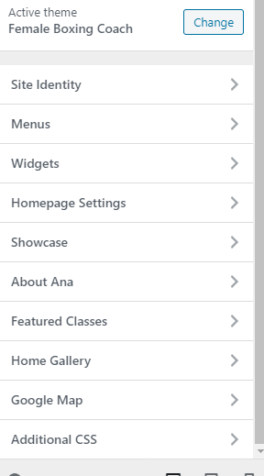Then click on ***GOOGLE MAP***



Here you can see one link – this is the link generated by google maps which you can get following the tutorial – if it doesn’t make sense I’m more than happy to go through it with you! ☺

You can see the changes on the right so now your map has 2 class locations both with the lgbt colour pin.

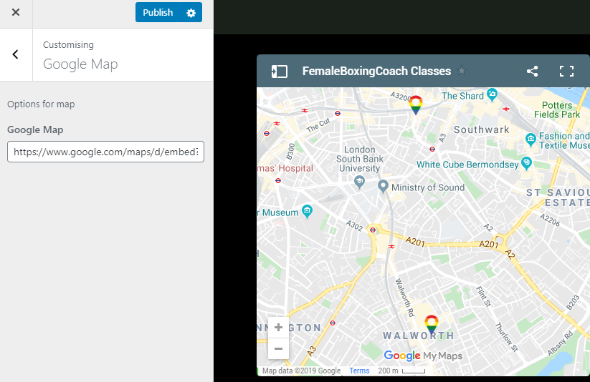

# EDITING THE ABOUT PAGE: - <http://www.femaleboxingcoach.com/>about/

## Editing the page:

This page is all about you! From dashboard - <http://www.femaleboxingcoach.com/wp-admin/> click on ***Pages*** -> ***All*** ***Pages***

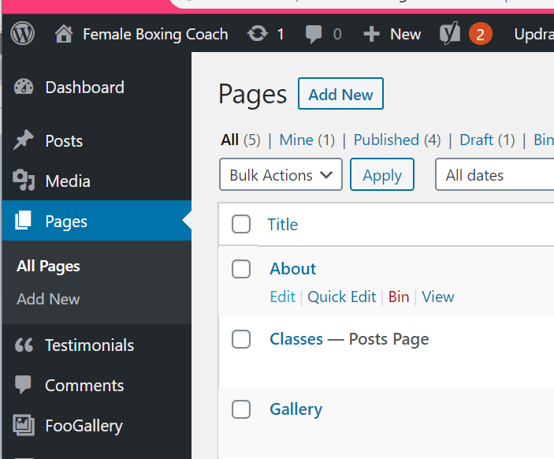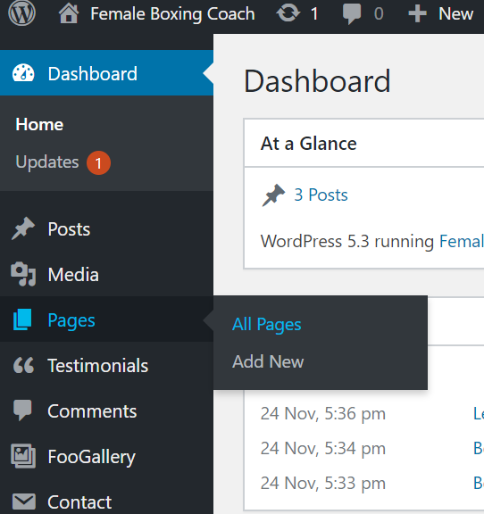

We will see the page below:

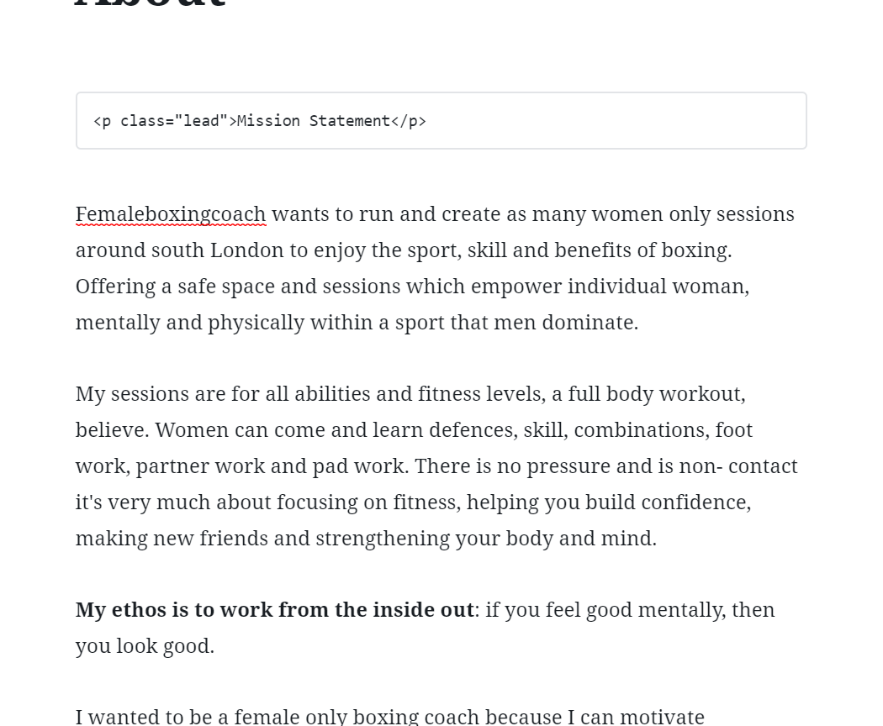

To edit a paragraph just click on it and you will see a little pop up like below – you can change text here or to delete the paragraph click on the three little dots and select ***REMOVE BLOCK***

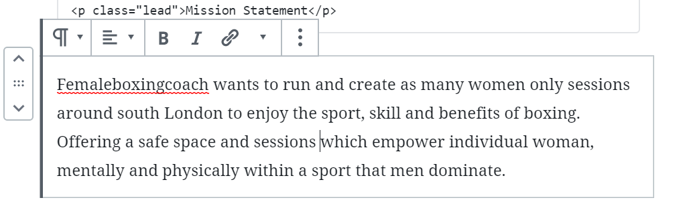

**Some of the sections will have a box saying ‘INVALID CONTENT’ or ‘CUSTOM HTML’ – please leave these where they are as they are needed to make the page look nice!**

**Examples are below:**

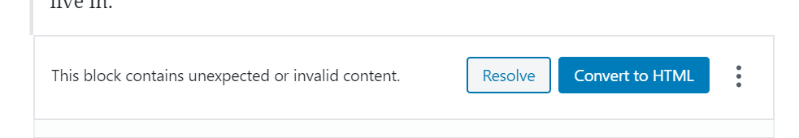

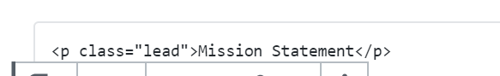

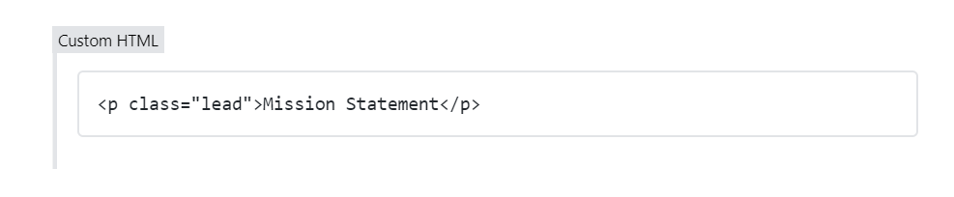

## To add a new paragraph:

Click on the **+** symbol at the top or at the place where you would like your new paragraph to go:

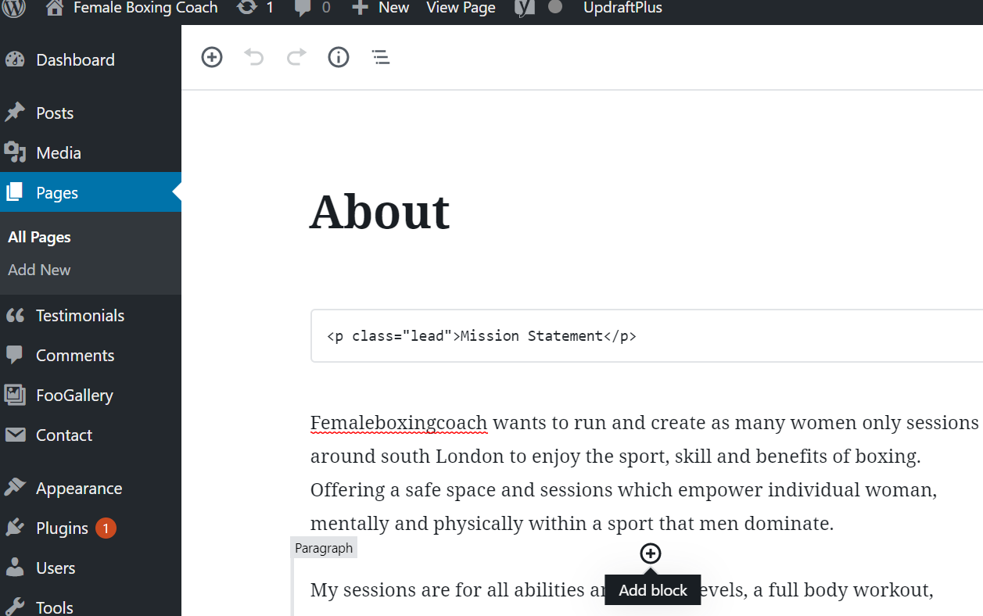

Once you have made your changes click on **UPDATE** – it’s the same as **PUBLISH**

If you are not ready to make it live and want to save it for later then click on **Switch to Draft**



# EDITING THE CLASSES PAGE - <http://www.femaleboxingcoach.com/>classes/

## Edit A Class to Classes Page

From the dashboard area: <http://www.femaleboxingcoach.com/wp-admin/>

***POSTS*** -> ***ALL POSTS***

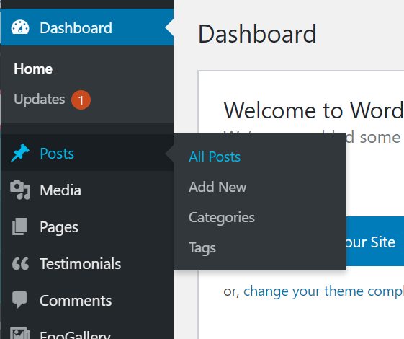

Here are your classes below – to edit hover over the class you want to make changes to and click on edit:

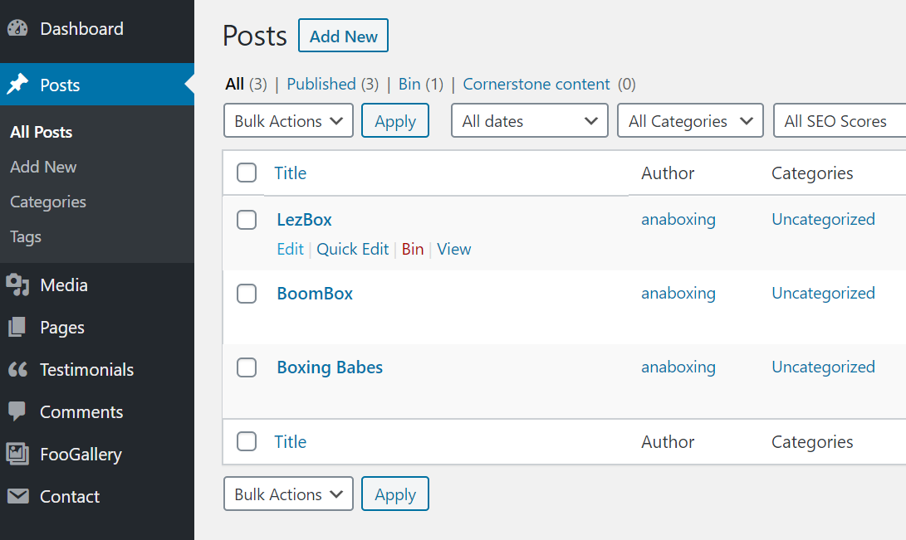

In this section we will need to edit some HTML but it’ easy!

Once you are in the class you want to edit you will see a block with CUSTOM HTML

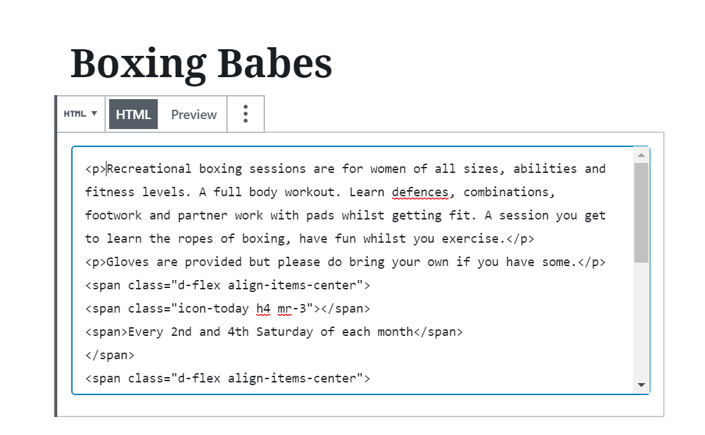

To edit just change the text like I have highlighted in bold:

<p>**Recreational boxing sessions are for women of all sizes, abilities and fitness levels. A full body workout. Learn defences, combinations, footwork and partner work with pads whilst getting fit. A session you get to learn the ropes of boxing, have fun whilst you exercise.**</p>

<p>**Gloves are provided but please do bring your own if you have some.**</p>

<span class="d-flex align-items-center">

<span class="icon-today h4 mr-3"></span>

<span>**Every 2nd and 4th Saturday of each month**</span>

</span>

<span class="d-flex align-items-center">

<span class="icon-clock-o h4 mr-3"></span>

<span>**10am-11am**</span>

</span>

<span class="d-flex align-items-center">

<span class="icon-room h4 mr-3"></span>

<span>**The Bridge (woman only gym) 73-81 Southwark Bridge Rd, London, SE1 0NQ**</span>

</span>

<span class="d-flex align-items-center">

<span class="icon-monetization_on h4 mr-3"></span>

<span>**£10 per person (Card and Cash payments accepted)**</span>

</span>

Once you have made your changes click on **UPDATE** – it’s the same as **PUBLISH**

If you are not ready to make it live and want to save it for later then click on **Switch to Draft**



## Add A New Class to Classes Page

To add a new class

From dashboard area: <http://www.femaleboxingcoach.com/wp-admin/>

***POSTS*** -> ***ALL POSTS***

Click on ***ADD NEW***:



Click on the **+** to add a new block:

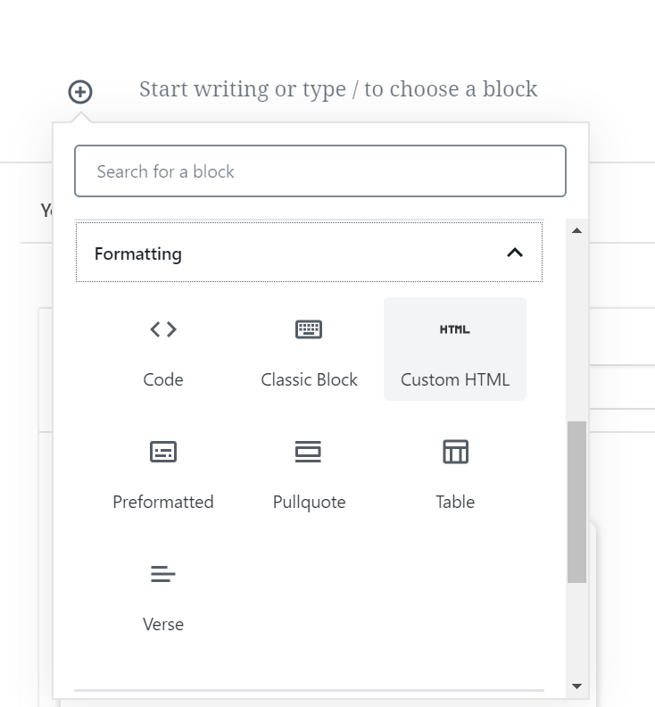Scroll down to the **formatting** section and click on the arrow then select ***CUSTOM HTML***

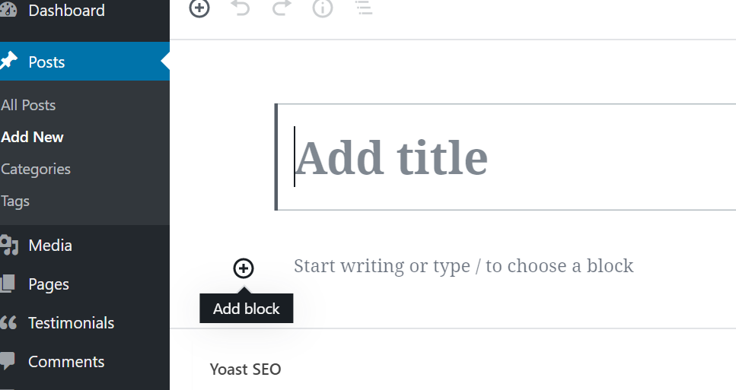

Type in the **ADD TITLE** section the name of your class

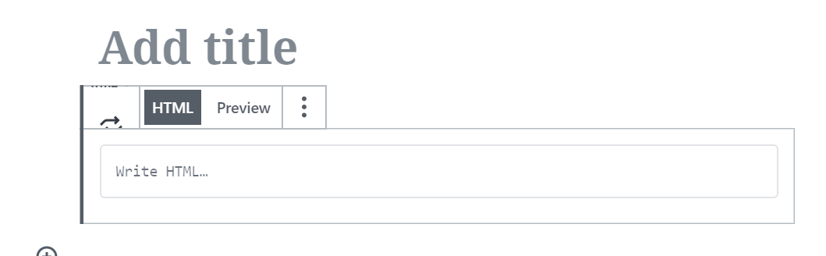

Copy and paste the following into the section that says “**Write HTML**” – make sure to change the black text you need for your new class!

<p>**CLASS DESCRIPTION GOES HERE**</p>

<p>**ANOTHER PARAGRAPH HERE IF YOU NEED IT!**</p>

<span class="d-flex align-items-center">

<span class="icon-today h4 mr-3"></span>

<span>**DAYS**</span>

</span>

<span class="d-flex align-items-center">

<span class="icon-clock-o h4 mr-3"></span>

<span>**TIMES**</span>

</span>

<span class="d-flex align-items-center">

<span class="icon-room h4 mr-3"></span>

<span>**LOCATION**</span>

</span>

<span class="d-flex align-items-center">

<span class="icon-monetization_on h4 mr-3"></span>

<span>**PRICE**</span>

</span>

So we will have something that looks like the below:

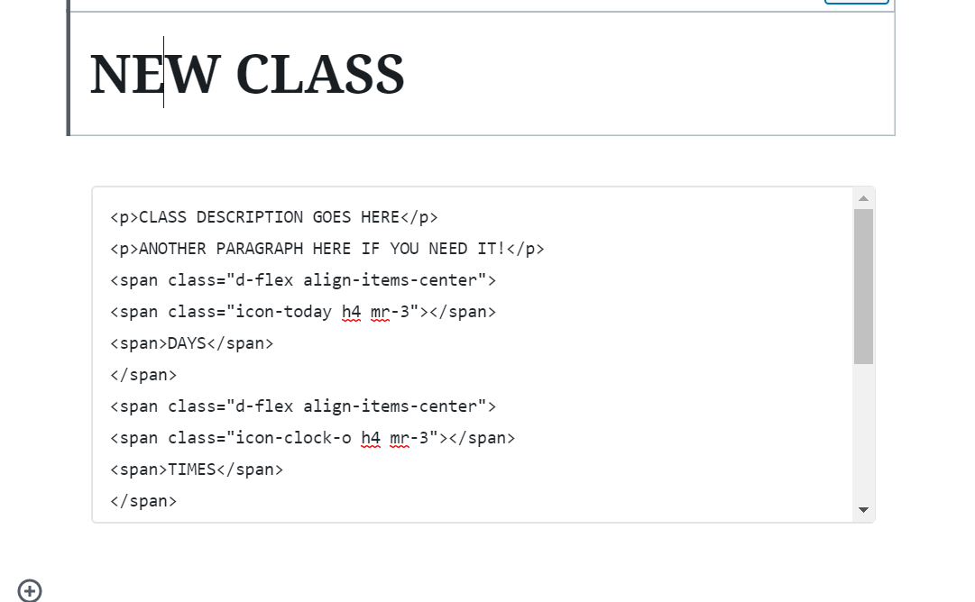

Once you have made your changes click on ***PUBLISH***

If you are not ready to make it live and want to save it for later then click on ***Switch to Draft***

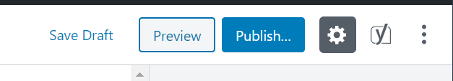

Once published we can see it live on the website:

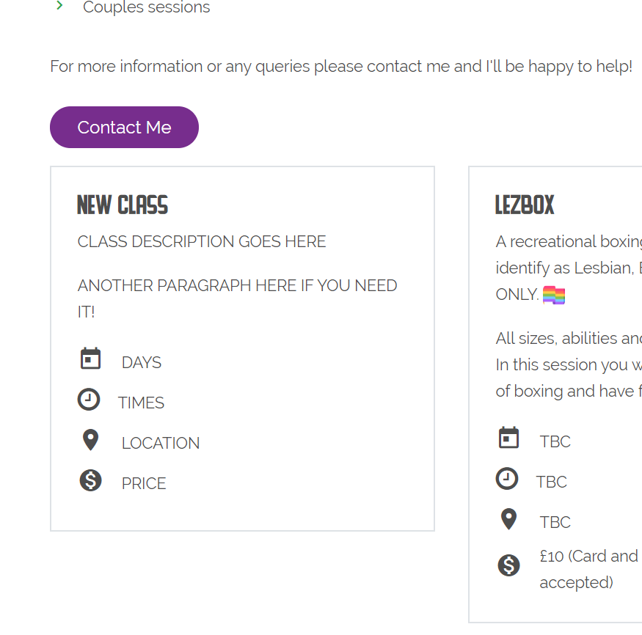

## To delete a class

Go to your dashboard are: <http://www.femaleboxingcoach.com/wp-admin/>

***POSTS*** -> ***ALL POSTS***



Hover over the class you would like to delete: in this case I’ll delete the test class I just made above – click on **Bin** and that’s it!

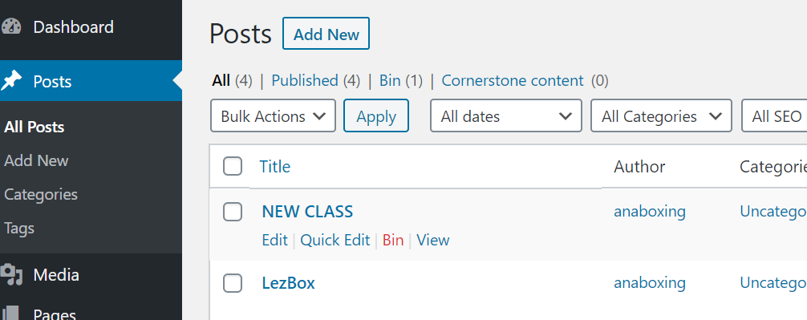

# EDITING THE GALLERY PAGE - <http://www.femaleboxingcoach.com/>gallery/

## Add A New Picture to The Gallery Page

Go to your dashboard are: <http://www.femaleboxingcoach.com/wp-admin/>

***FOOGALLERY*** -> ***GALLERIES***

*Hover over* ***Gallery*** *and click on* ***Edit***

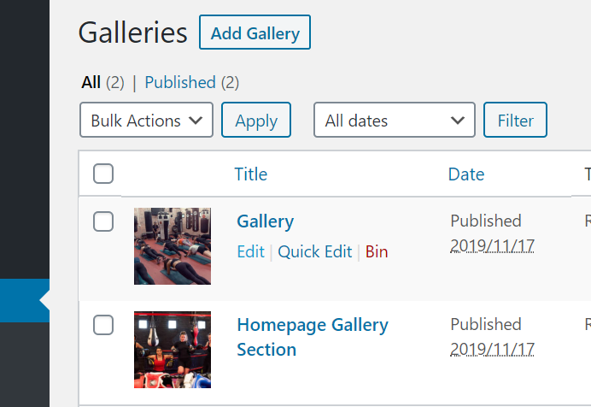

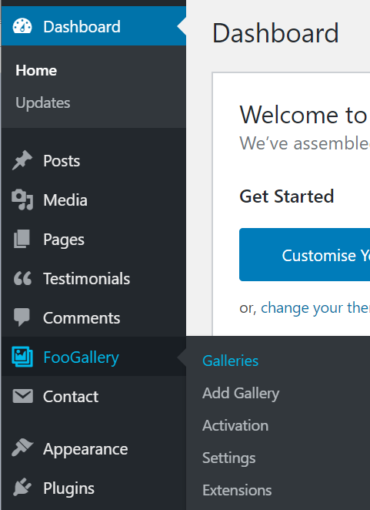

Click on **Manage Items**

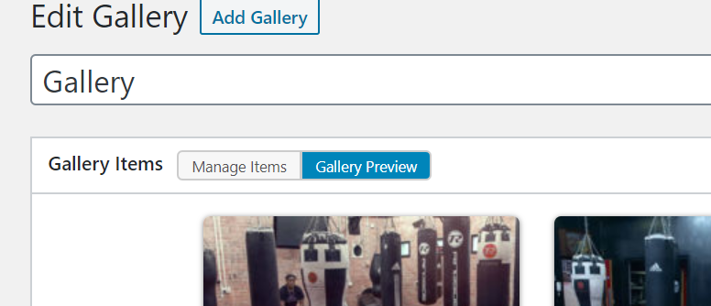

Now we can add or delete images – to add a new image scroll to the bottom and click on the + image

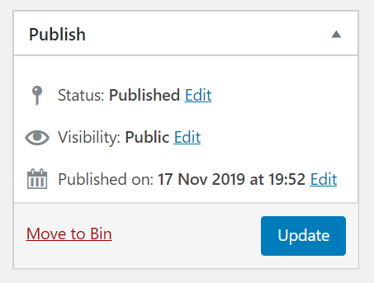You can then add or upload an image the same way as in the uploading new images section and save your changes by clicking on **UPDATE**

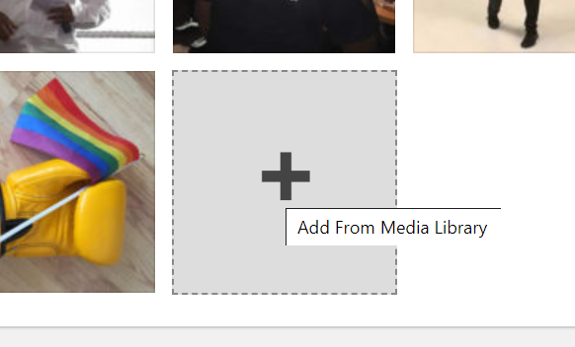

## Delete an image from the Gallery Page

To delete an image from your gallery page – hover over the image you no longer want and click on the **X**

Done!

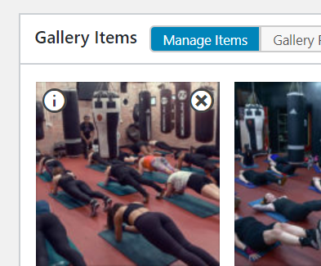

# UPDATES TO YOUR SITE

Sometimes when you log into Wordpress you will see a little red circle with a number in it beside **Plugins** and/or the **updates** section,

If you click on either of these it will take you to the update section, then select the checkbox for **Select All** and then click **UPDATE PLUGINS**

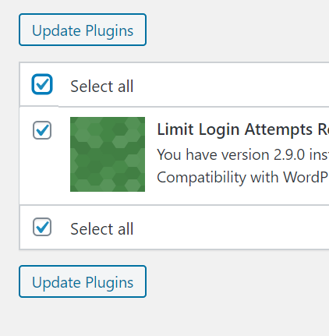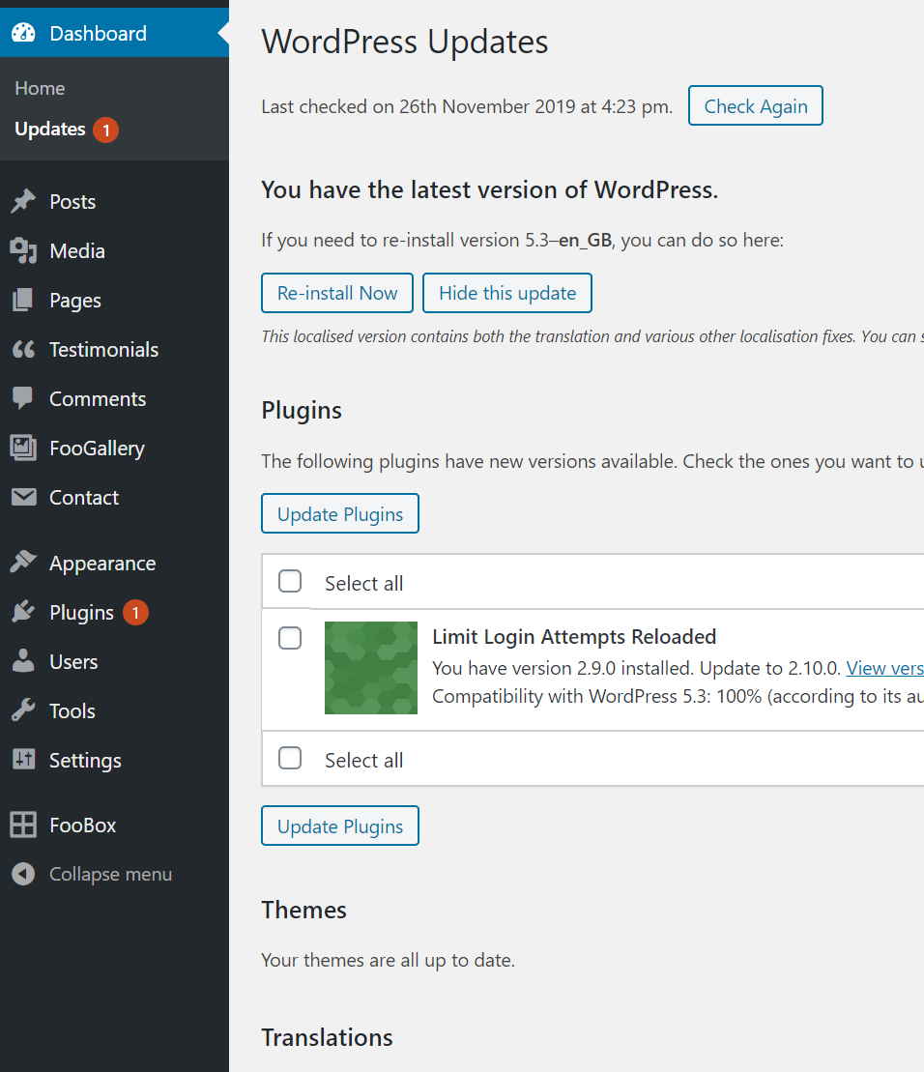

All done!

# BACK UPS

These are scheduled to be backed up to your email address every month – this is just in case anything happens to your website – it is always good to have a backup! If you’d prefer it to be on dropbox or google drive let me know and I can change that for you :)

Using the plugin